**Commodore Port Breakout: 2x12 Breakout Rev. 0**

**Module Description**

# Introduction

This assembly serves as a breakout board for the Commodore PET User Port and IEEE-488 port. It is also suitable for the C64, C128 and VIC-20 user port. The purpose is connecting it to the User Port Output or the IEEE-488 Output board via a ribbon cable. Further it can be used to connect one of those ports to a bread board or even to a ribbon cable with a 24p Centronics connector as an IEEE-488 cable.

Every pin of the edge connector is connected to a pin of the (2x13p) box connector/pin header. The “GND” pins of the user port or the IEEE-488 port are not wired with each other on this PCB, so it can have a universal use. They will be connected on the respective output port, though.

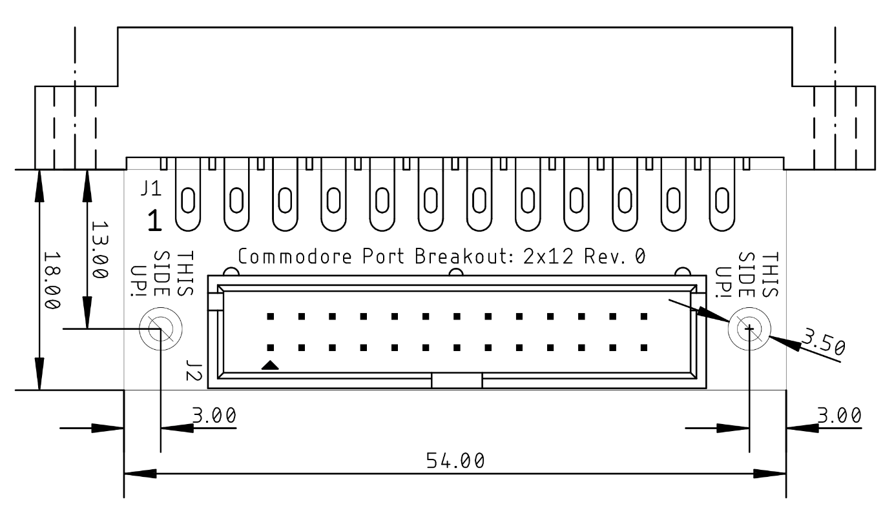

Figure 1: Dimensions of the PCB

# Connector Pinout

|  |  |  |  |  |  |
| --- | --- | --- | --- | --- | --- |
| J1 | PET User Port | IEEE-488 | C64 User Port | VIC-20 User Port | J2 |
| 1 | GND(1) | DIO1 | GND(1) | GND(1) | 1 |
| 2 | TVVIDEO | DIO2 | +5V | +5V | 3 |
| 3 | IEEESRQ | DIO3 |  |  | 5 |
| 4 | IEEEEOI | DIO3 | CNT1 | JOY0/PA2 | 7 |
| 5 |  | EOI | SP1 | JOY1/PA3 | 9 |
| 6 | TPREAD2 | DAV | CNT2 | JOY2/PA4 | 11 |
| 7 | TPWRITE | NRFD | SP2 | LIGHT PEN/PA5 | 13 |
| 8 | TPREAD1 | NDAC |  | CASSETTE SWITCH/PA6 | 15 |
| 9 | TVVERT | IFC | ATN IN | ATN IN | 17 |
| 10 | TVHOR | SQR | 9VAC(1) | 9VAC(1) | 19 |
| 11 |  | ATN | 9VAC(2) | 9VAC(2) | 21 |
| 12 | GND(12) | GND(12) | GND(12) | GND(12) | 23, 25 |
| A | GND(A) | DIO5 | GND(A) | GND(A) | 2 |
| B | CA1 | DIO6 |  | CB1 | 4 |
| C | PA0 | DIO7 | PB0 | PB0 | 6 |
| D | PA1 | DIO8 | PB1 | PB1 | 8 |
| E | PA2 | REN | PB2 | PB2 | 10 |
| F | PA3 | GND(F) | PB3 | PB3 | 12 |
| H | PA4 | GND(H) | PB4 | PB4 | 14 |
| J | PA5 | GND(J) | PB5 | PB5 | 16 |
| K | PA6 | GND(K) | PB6 | PB6 | 18 |
| L | PA7 | GND(L) | PB7 | PB7 | 20 |
| M | CB2 | GND(M) | PA2 | CB2 | 22 |
| N | GND(N) | GND(N) | GND(N) | GND(N) | 24, 26 |

# Revision History

## Rev. 0

* Prototype